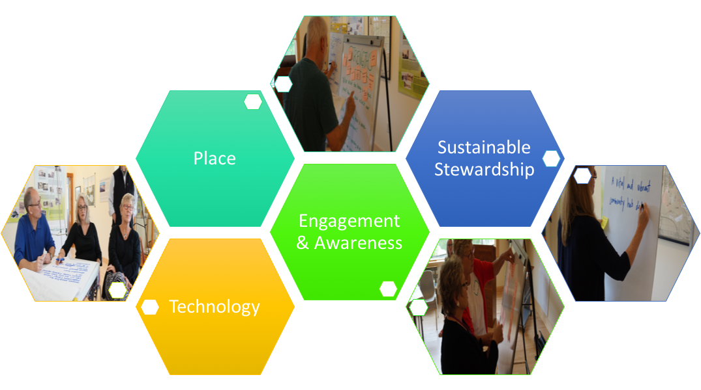

Leland Township
Public Library
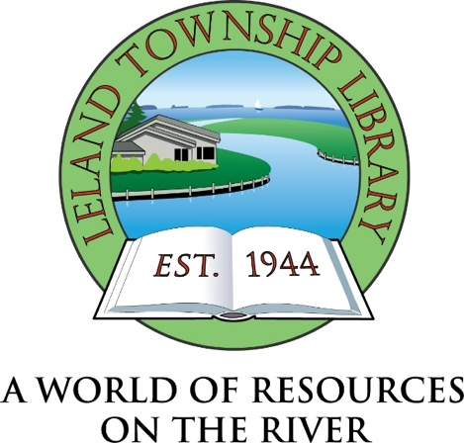
Strategic Plan
2018-2020

203 E. Cedar Street, P.O. Box 736 Leland, MI 49654-0736 231-256-9152
Leland Township Public Library
Strategic Plan
2018-2020

Adopted by the
Leland Township Public Library
Board of Directors
December 11, 2017

Strategic Plan Facilitators : Michelle Bradley Midwest Collaborative for Library Services

David Votta
Midwest Collaborative for Library Services

A summary of this document is available online at the Library’s website:
www.lelandlibrary.org

Table of Contents

Message from the Director 4

Acknowledgements 5

Strategic Planning Committee Members 6

Board of Directors 7

Community Leaders Interviewed 8

Community Conversation Participants 9

Executive Summary 10

Overview of the Planning Process 11-12

Strategic Plan Overview 13-17

Appendix A: Community Narrative
Appendix B: Goals and Objectives
Appendix C: Measurement Plan
Appendix D: Implementation Timeline

Message from the Director

November 2017

The diversity of the varied communities and populations we as a public library serve pose unique and exciting challenges for the Leland Township Public Library. We strive to find the best balance in offering programs and services that will meet our mission to provide equal and open access to Library materials, resources, and services for the enjoyment, education and enrichment of residents and visitors of all ages.

We believe that libraries are ‘the fabric of thriving communities’ with the opportunity to connect, engage, inform and educate those we serve. We want to continually ‘reimagine’ our Library and work to expand beyond the traditional role of lending materials, while continuing to maintain that important, democratic service.

In order to remain relevant in an ever-changing world, libraries must continuously evolve to meet the changing needs of their communities. To that end, the Leland Library Board and staff engaged our communities in a strategic planning effort over the past six months. The results from these conversations formed the framework that will now guide us in making intentional, community-centered judgements and choices that will be our road map toward achieving greater impact and relevance in our community.

Thank you to all those who took up this challenge and helped in this process. It was rewarding and productive. I am excited by the directions your input will now take us in re-imagining the Leland Township Public Library into the 21st Century.

Sylvia Merz
Director

Acknowledgements

The development of the strategic plan took many hours and the dedicated effort of many people. We would like to extend our sincere thanks to all those who helped make this plan a reality.

- The Library staff for their contributions to the process, and who will ultimately make this plan succeed.

- The members of the Library Board of Directors for their participation and support of the process.

- The members of the Strategic Planning Committee for their time and expertise in interviewing community leaders and participating in a time-consuming planning meeting.

- The community leaders who agreed to be interviewed for this process, as well as the community members who attended community conversations and shared their aspirations for the community.

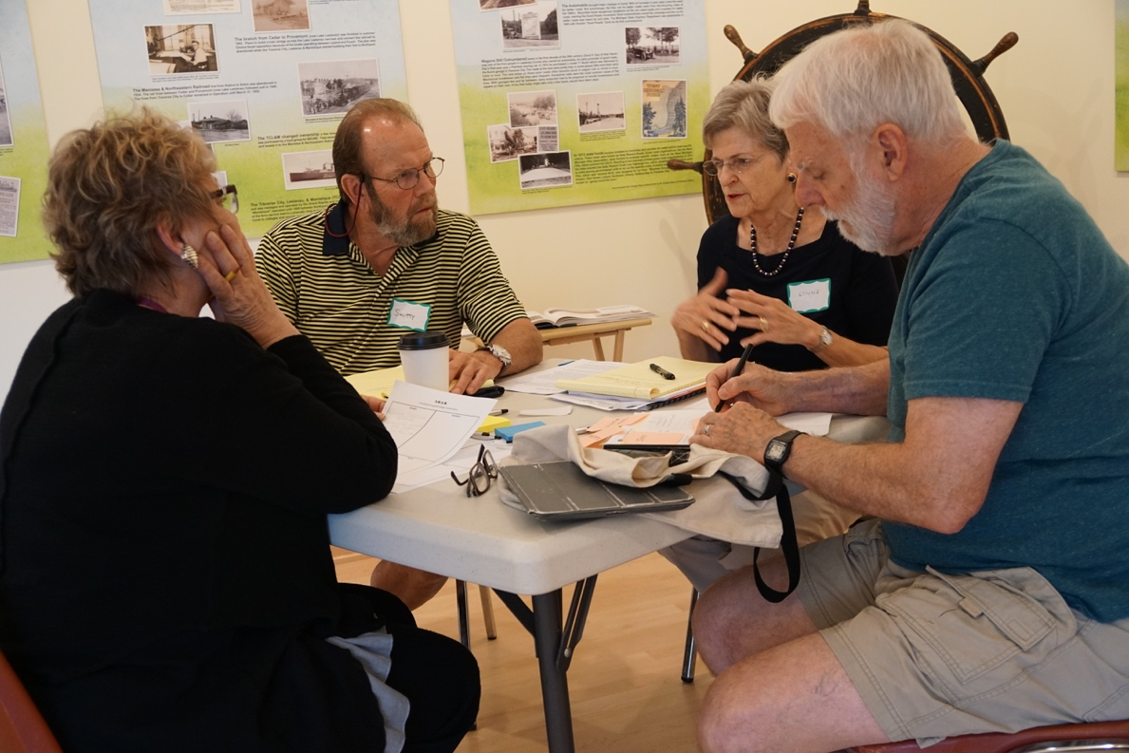
Strategic Planning Committee Members

Berkley Duck, Library Board President
Laurie Leppink Lisuk, Library Board Member
Sylvia Merz, Library Director
Jane Suppes, Library staff member
Lynne Lyons, Chairperson, Friends of the Leland Township Library
Tim Stein, Cleveland Township Supervisor
Jeanne Gross, Leland Public School teacher
Kim Kelderhouse, Leelanau Historical Society
David Bison, Library patron
Lisa Bison, R.N. and Library patron
Jim Carpenter, 8180 Films co-owner
Cindy Jones, Chase Bank, Cleveland Township

Board of Directors

Berkley Duck, President

Georgia Rivers, Vice President

Bret Crimmins, Treasurer

Robert Soutas-Little, Secretary

Powell Smith, Member

Laurie Leppink Lisuk, Member

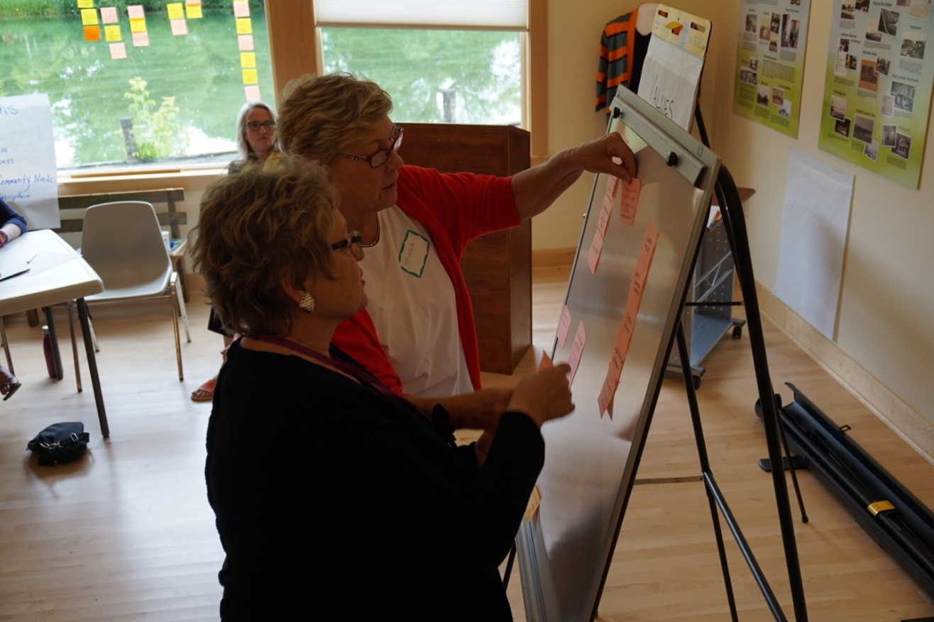
Community Leaders Interviewed

Joe Charlevoix Bea Cruz
Karen Kirt Dan Stewart
Steve Hoskins Susan Och
Erik Zehender Linda Lindquist Bishop
Barb Duvall Patricia Soutas-Little
Garth Goodenow Jo-Ellen Walker
Carolyn and Laddie Zalud Sarah Jane Johnson
Dan Lisuk Ron Plamondon

Community Conversation Participants

Bret Crimmins
Trudy Underhill
Jim & Susann Schaberg
Jessica Lukomski
Judy Brown
Bud & Lucy Boesel
Laurie Leppink Lisuk
Patricia Stewart
Ryan Eby
Hank & Sue Holt
Ann Watkins
Alan McKisson
Georgia Rivers
Jim Schwantes
Elise Shatto
Michael Collins
Jennie Berkson
Alan Hartwick
Sue Dennis
Patty Shea
Nancy & Berkley Duck
Kathryn Omoto
Pastor Joshua LaFeve
Powell Smith
Donna Stowe

Executive Summary

The Board and Staff of the Leland Township Public Library believe that libraries are “the fabric of thriving communities” with the opportunity to educate, convene, inspire and connect. We wanted to “reimagine” our Library and work to expand beyond the traditional role of borrowing materials while continuing to maintain that important service.

In order to guide this effort, the Board elected to work with consultants at the Midwest Collaborative for Library Services of Lansing, Michigan, to facilitate a strategic planning process that would help to align Library services with the aspirations and needs of the community. Based on the work of the Harwood Institute for Public Innovation, community members were asked “What kind of community do you want?” and “How can the Library help?”

The Strategic Planning Committee recommended that the Library Board adopt four strategic priorities for the period 2018-2020. The priorities are:

PRIORITY: SUSTAINABLE STEWARDSHIP
The Library will be responsible and transparent in the wise use of our community’s resources, will plan for the future, honor the past, and be committed to fiscal sustainability.

PRIORITY: ENGAGEMENT AND AWARENESS
The Library will engage with all segments of the community to provide services to improve the quality of their lives, work collaboratively with other organizations, and strive to make all aware of the valuable resources available to them at the Library.

PRIORITY: TECHNOLOGY
The Library will be a community resource for digital literacy, providing access, equipment, and education to meet the needs of residents and visitors.

PRIORITY: PLACE
The Library will provide a “sense of place” for the community, by serving as a safe and welcoming hub for meetings, gatherings, programs, and ideas for all ages and abilities.

Overview of the Planning Process

- The Library Board approved working with consultants from the Midwest Collaborative for Library Services (MCLS) to facilitate the creation of a new strategic plan that would be based on community needs. MCLS, based in Lansing, Michigan, is a non-profit, member-driven organization whose mission is to facilitate sharing resources and to collaborate with other organizations to benefit Michigan and Indiana libraries. MCLS was seeking a library to work with in piloting its new planning process, based on the Harwood Institute for Public Innovation’s “Turning Outward” approach. “Turning Outward” is a process that entails taking steps to better understand communities, changing processes and thinking to make conversations more community-focused, being proactive to community issues and putting community aspirations first.

- A twelve-person Strategic Planning Committee was assembled, which included representatives from the Library Board, the Library Staff, the Friends of the Library and community members.

- At an initial meeting with the consultants, Library staff and board members developed a list of community leaders to be interviewed and a strategy to invite community members to participate in community conversations. The participants were selected with a view to representation of as many groups and stakeholders in Leland Township as was possible.

- Strategic Planning Committee members were each assigned two community leaders to interview. The interview was based on the Harwood Institute’s “Ask” exercise, which entailed asking five simple questions to get a sense of people’s aspirations for the community and how the Library might help the community to achieve those aspirations.

- MCLS consultants, Michelle Bradley and David Votta, conducted four “Community Conversations” with 29 community members in June, 2017. These conversations were 90 to 120 minutes long and focused on what the interviewees wanted their community to be, what challenges would be faced in realizing these aspirations and how the Library might help in doing so.

- MCLS consultants compiled the information from the community leader interviews and the community conversations to identify themes and then created a “Community Narrative” that summarized the knowledge that was gathered.

- The MCLS consultants also created a data package that included a benchmarking report, five-year Library usage statistics, and demographics. The consultants then benchmarked data points from the Leland Township Public Library against six other Michigan libraries of similar size and six other national libraries of similar size and with similar annual budgets, in order to illustrate how the Leland Township Public Library stands in relation to its peers. Additionally, the consultants compiled and analyzed Library usage statistics over a five-year period; examining uses such as circulation of materials, Library visits, collection holdings, program attendance, etc., in order to identify trends. Lastly, the consultants reviewed local demographic information, including population projections and poverty levels.

- The Strategic Planning Committee met on July 12 to review the data package and community input summary. This was followed by the group participating in an analysis of the Library, identifying strengths, opportunities, aspirations, and results (SOAR). The strengths provided the basis for the development of the Library’s core values, the opportunities resulted in the identification of four key strategic priorities, and the aspirations became the basis of the Library’s vision statement.

- On August 3, the MCLS consultants returned to the Leland Township Public Library to work with all Library staff and board members on the creation of a tactical plan to address the key strategic priorities that were identified by the strategic planning committee. The group answered the following questions for each priority:

- What will the customer experience?
- How will the community benefit?
- What activities might occur?
- What will success look like?
- What organizational issues will need to be addressed?
This work created the basis for the development of goals, objectives and activities that make up the three-year strategic plan.

LELAND TOWNSHIP PUBLIC LIBRARY

VISION
Our vision is to be a sustainable community hub dedicated to vital and vibrant collaborative engagement, innovation, and lifelong enrichment.

MISSION
To provide equal and open access to Library materials, resources and services for the enjoyment, education and enrichment of Leland Township residents and visitors of all ages.

CORE VALUES
Delivering Excellent Service
Offering an Inspirational Climate
Providing High Quality and Diverse Programs and Collections
Being a Trusted Community Partner

KEY STRATEGIC PRIORITIES
2018-2020

Sustainable Stewardship
The Library will be responsible and transparent in the wise use of our community’s resources, will plan for the future, honor the past, and be committed to fiscal sustainability.

Engagement and Awareness
The Library will engage with all segments of the community to provide services to improve the quality of their lives, work collaboratively with other organizations, and strive to make all residents aware of the valuable resources available to them at the Library.

Technology
The Library will be a community resource for digital literacy, providing access, equipment, and education to meet the needs of patrons.

Place
The Library will provide a “sense of place” for the community by serving as a safe and welcoming hub for meetings, gatherings, programs, and ideas for all ages and abilities.
THE PLAN

SUSTAINABLE STEWARDSHIP
The Library will be responsible and transparent in the use of our community’s resources, will plan for the future, honor the past, and be committed to fiscal sustainability.

THE PATRONS WILL EXPERIENCE:
- The continued availability of high quality services, resources and facilities
- The ability to participate in the library’s work as a steward through volunteer time, talent and money
- Confidence in the future of the Library

THE COMMUNITY WILL BENEFIT FROM:
- Facilities, services and collections that will grow in response to a continuous assessment of community needs
- Pride in place
- A sense of ownership
- Access to valuable resources

THE LIBRARY WILL:
- Develop a fundraising plan to create multiple avenues for donor contributions
- Clarify the role of the Friends of the Library
- Enhance the donor recognition process
- Conduct periodic analyses of staff salaries and benefits
- Investigate the possibility of District library status

INDICATORS OF SUCCESS WILL INCLUDE:
- Effective development and maintenance of a broader and more effective volunteer corps
- Recruitment and retention of a high-quality staff
- Voter renewal of the Library’s millage support when needed
- Increased donor support of the Library
- Increased use of the Library by local residents and by visitors

ENGAGEMENT AND AWARENESS
The Library will engage with all segments of the community to provide services to improve the quality of their lives, work collaboratively with other organizations, and strive to make everyone aware of the valuable resources available at the Library.

PATRONS WILL EXPERIENCE:
- Staff that help bridge the gap between their current skills/knowledge and their needs
- Programs and services that meet their needs
- Staff that make them feel welcome, encouraged and supported

THE COMMUNITY WILL BENEFIT FROM:
- Having a place in which everyone is welcome and comfortable
- Having more informed, engaged, and connected community members
- Having a library that they can be proud of and that is a model for other communities

THE LIBRARY WILL:
- Improve the user experience on the website
- Assess current programs and services and prioritize in response to community needs
- Increase interactions with other community organizations and groups
- Investigate ways for community members to access Library resources outside normal business hours
- Investigate ways to increase or alter the Library’s hours of operation

INDICATORS OF SUCCESS WILL INCLUDE:
- Off-site resources and programs will be well used
- There will be an increased use of the Library by new patrons
- Use of all Library services will increase

TECHNOLOGY
The Library will be a community resource for digital literacy, providing access, equipment, and education to meet the needs of residents and visitors

PATRONS WILL EXPERIENCE:
- Modern, up to date, user-friendly technology
- Quiet, private spaces in which to use that technology
- Staff who can support the public in their use of technology
- Increased knowledge and confidence in using technology
- High speed wireless access to the Internet and printing

THE COMMUNITY WILL BENEFIT FROM:
- People who have equal access to high speed Internet and modern technology
- People who are technology savvy
- People who are globally connected
- Workforce support for entrepreneurs and remote workers
- Cost savings for residents through the use of the community’s resources

THE LIBRARY WILL:
- Evaluate alternative times for technology classes so as to reach more residents
- Evaluate adding advanced classes
- Investigate adding additional educational programs
- Offer STEAM programming (Science, Technology, Engineering, Arts, and Math)
- Offer exposure to a wide-range of technologies

INDICATORS OF SUCCESS WILL INCLUDE:
- More people will participate in technology training classes
- People will be more confident with computer use and accessing Library services
- People will have improved skills in evaluating the quality of online information
- Greater usage of Library resources by teens and tweens

PLACE
The Library will provide a “sense of place” for the community, by serving as a safe and welcoming hub for meetings, gatherings, programs, and ideas for all ages and abilities.

PATRONS WILL EXPERIENCE:
- Designated spaces for targeted activities, such as children’s activities, quiet reading, and use of technology
- Access to Library materials and services at hours that meet their needs
- Space that is accessible and comfortable

THE COMMUNITY WILL BENEFIT FROM:
- A better informed and more engaged public
- Pride in place
- Exposure to a multitude of opportunities and conversations
- A place that is for everyone

THE LIBRARY WILL:
- Evaluate the use of the Library’s facility and grounds to meet changing needs (business center concept, quiet reading room, additional small group meeting space, etc.)
- Offer a diverse variety of programs and services that broaden people’s perspectives and meet their needs

INDICATORS OF SUCCESS WILL INCLUDE:
- People will say that they love the Library and recognize it as a necessary asset to the community
- People will be able to use the Library when they need it
- Diverse and interesting programs and services will increase usage

